**Team Members:**

Roshini Varada- 26

V H N V R S Sai Pavan -27

**Introduction:**

To create,install amd configure Amazon CLI

**Objective**

This has got three objectives.

1.To create an AWS user in aws account

2.To install AWS CLI

3.To configure AWS CLI

**Prerequisites:**

To create an account in the Amazon AWS.

**Design and Implementation:**

**Objective-1**

1.Login into the aws account

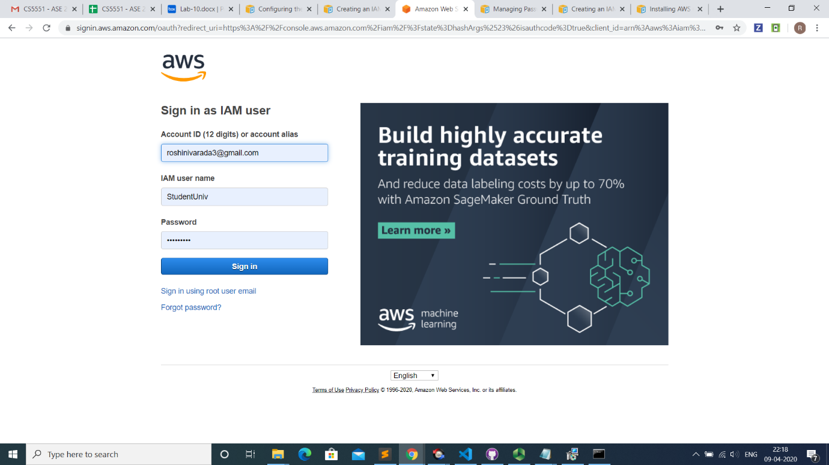

2.Go to the resource groups in the services.

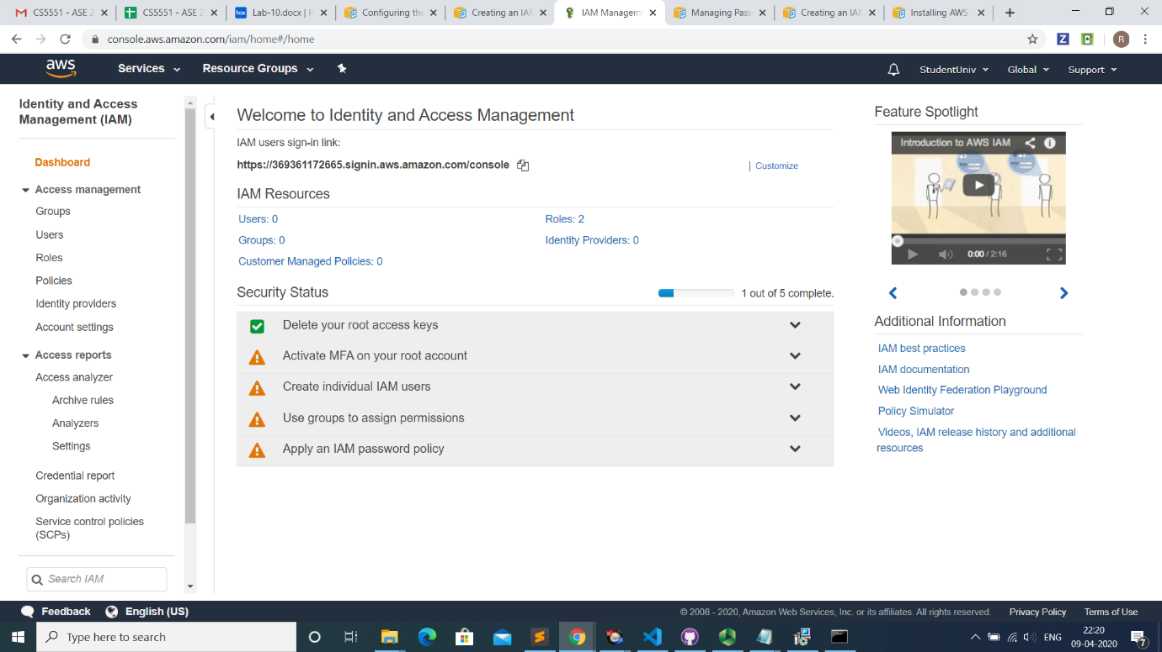

3.Select the users in the left side of the services.

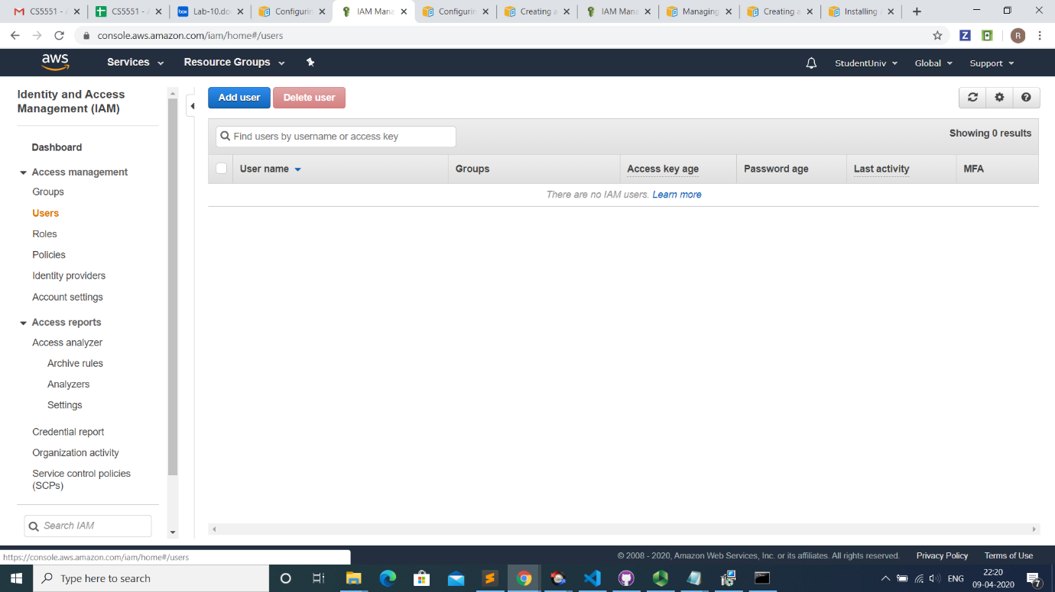

4.Add the user with the name needed and allocate the permissions.

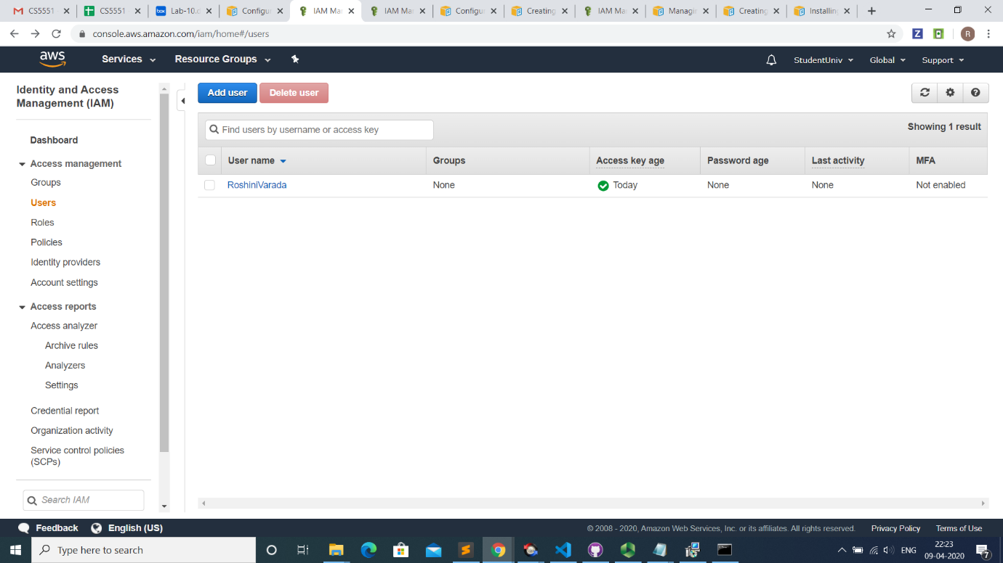

5.Go to the security credentials tab and generate the access keys and set the user status as active

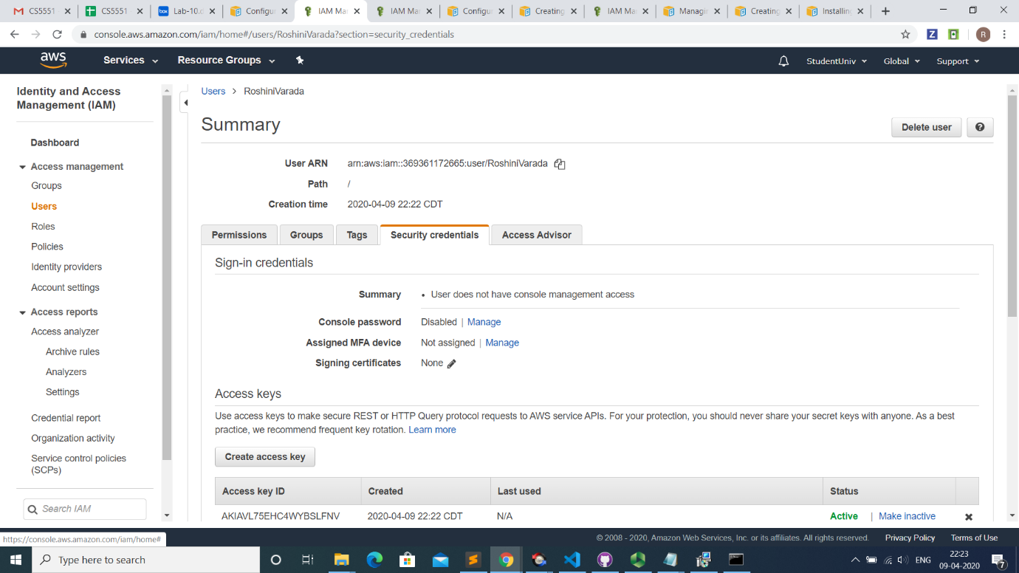

6.Note the security credentials of the user.

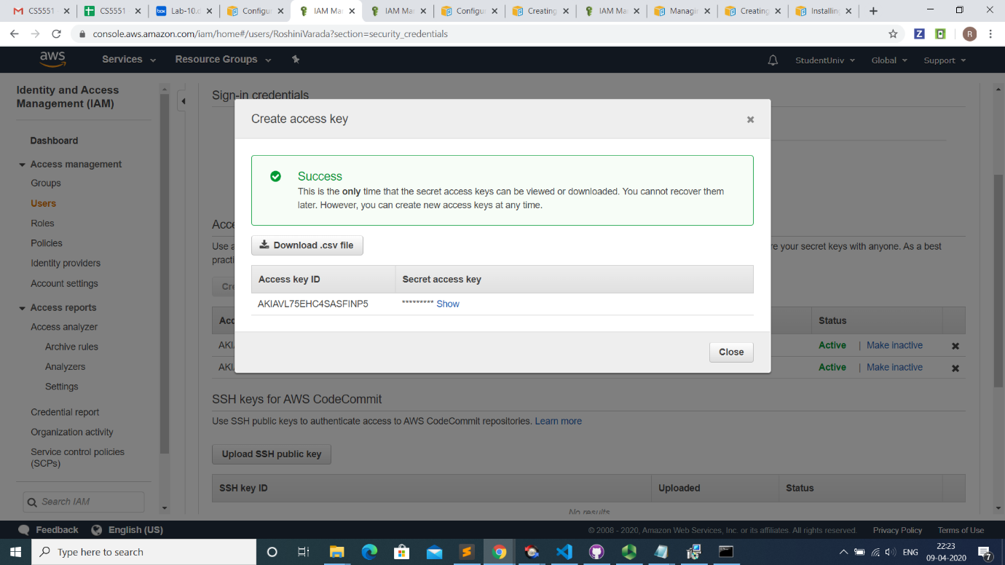

**Objective-2-Install the AWS Cli**

1. Go to <https://docs.aws.amazon.com/cli/latest/userguide/install-cliv2.> and install the CLI

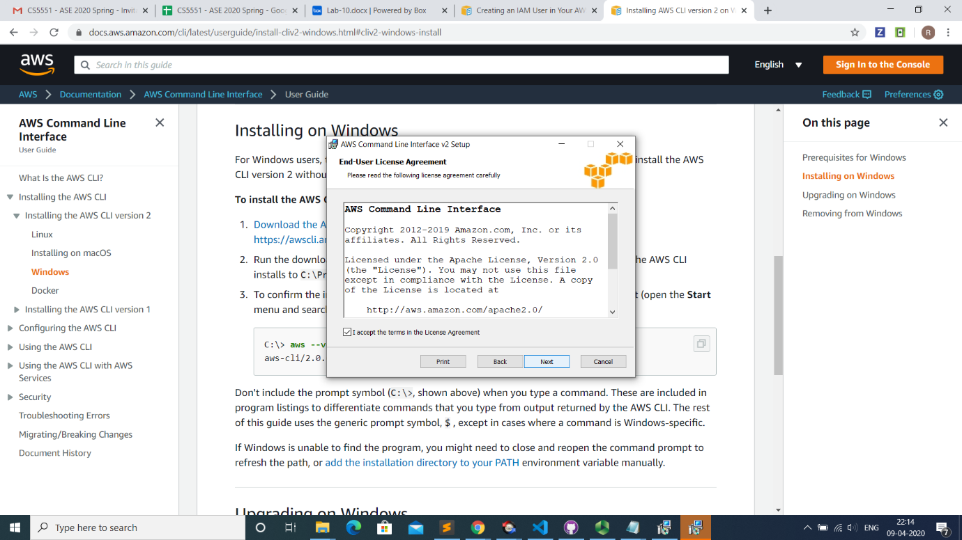

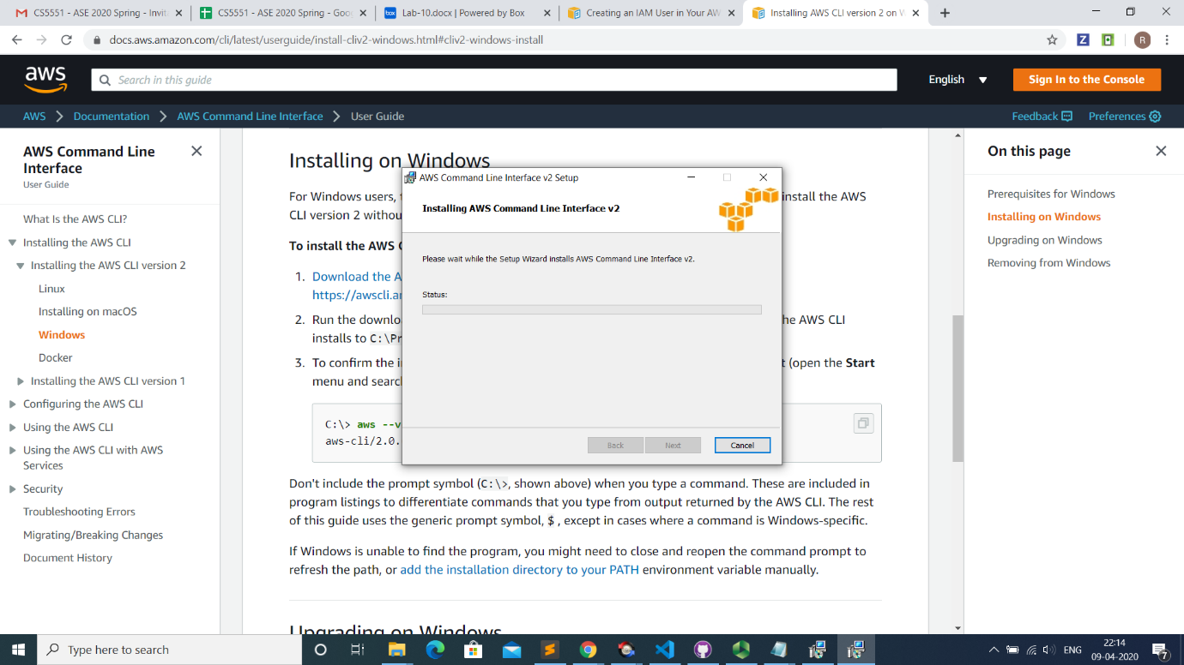

2.Open the AWS console and see the version of aws.

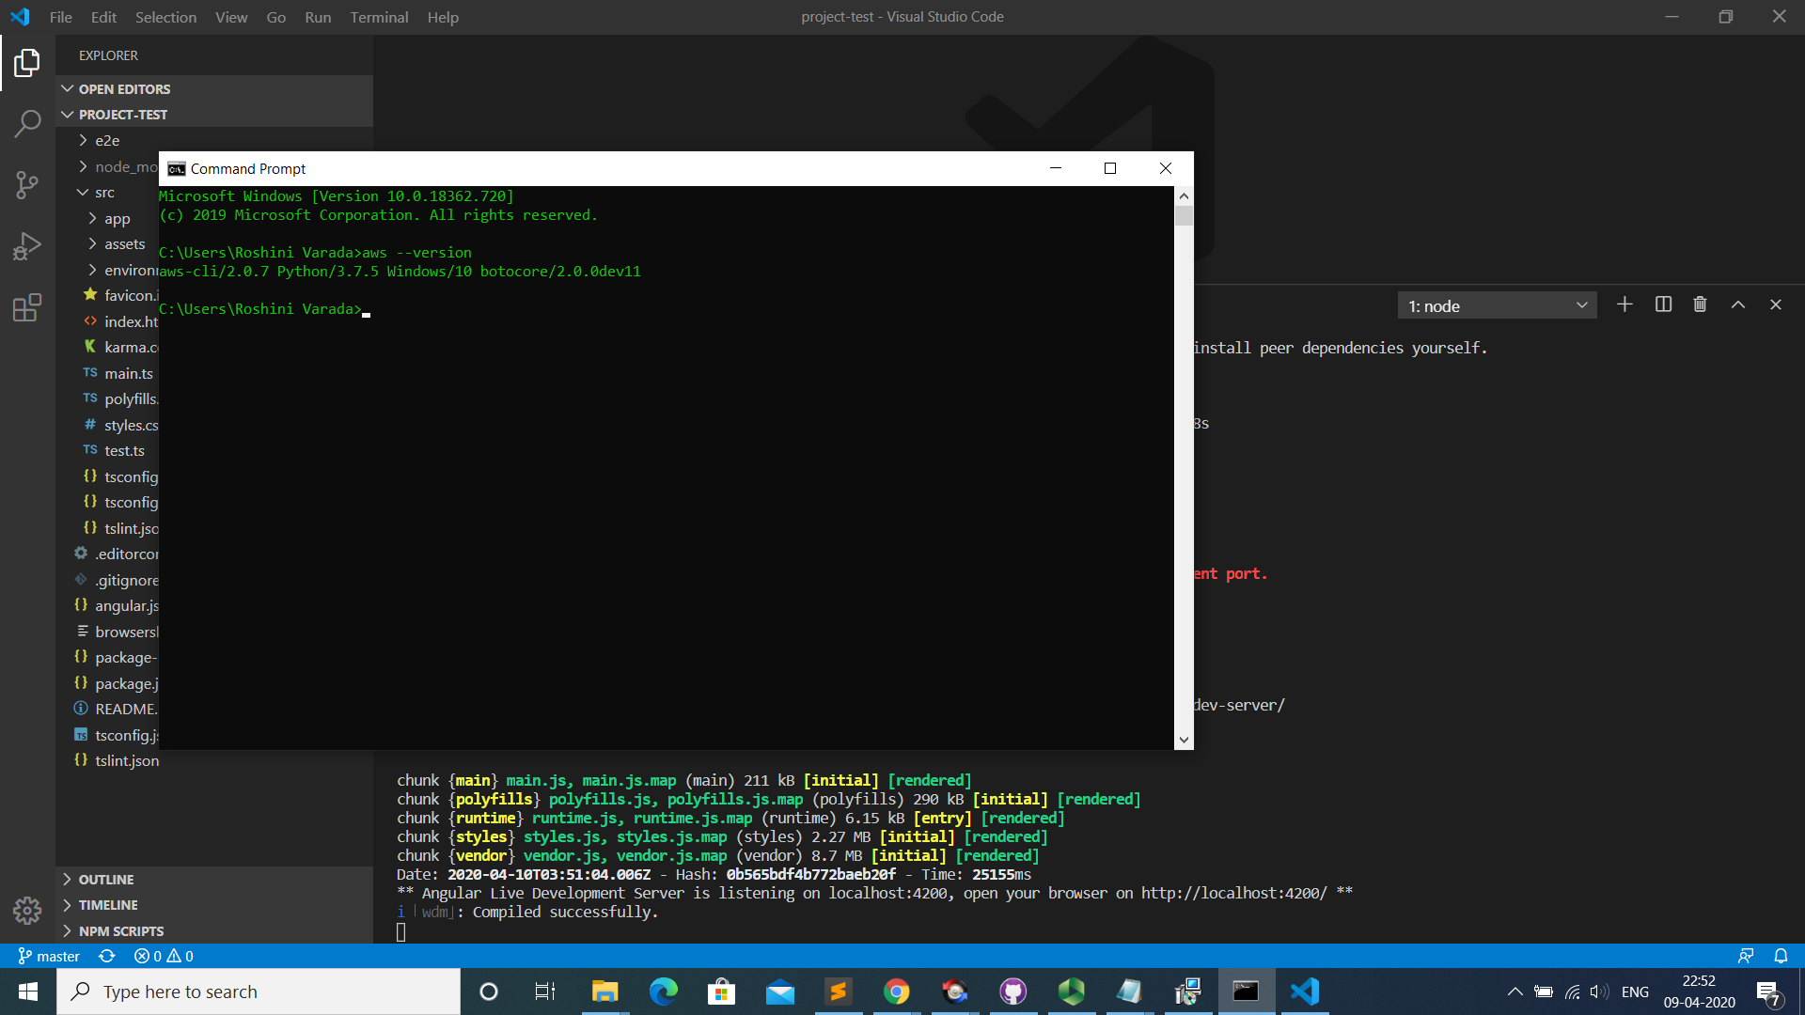

**Objective-3-Configure the AWS Cli**

1.After downloading the keys and installing the aws cli just check the aws –version to confirm the aws cli installation.

2.After that use the command aws configure profile –profilename to configure the details.

3.Set the access key,secret key ,region and format of output.

4.After configuring the credentials just check the access to s3 bucket using the command aws s3 ls –profile profilename

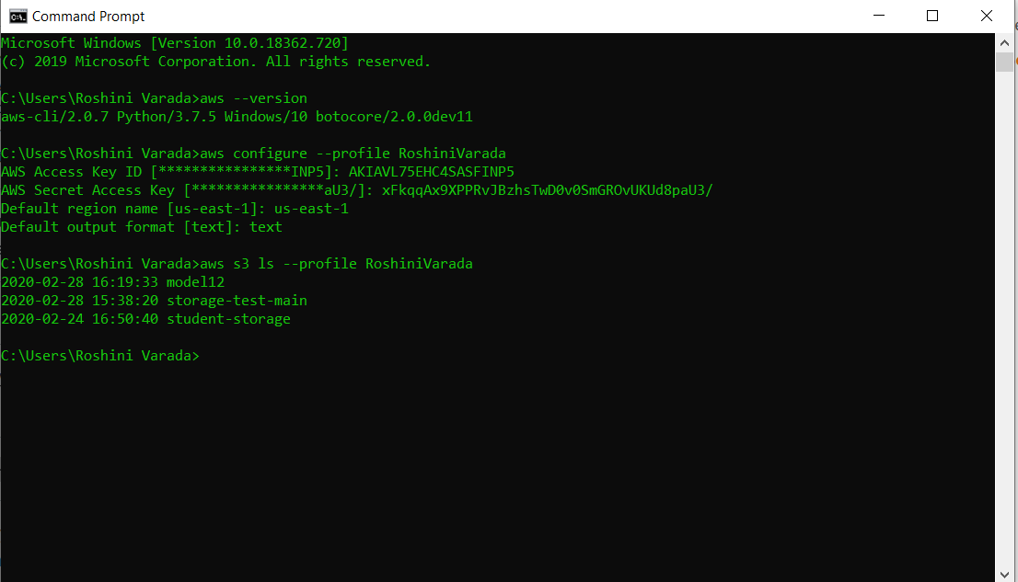

**Conclusion:**

Thus, an AWS user account can be created,AWS Cli can be installed and configured.

**YouTubeLink:**

<https://youtu.be/H9S99JgigFI>

**References:**

<https://docs.aws.amazon.com/cli/latest/userguide/install-cliv2.html>